Curriculum Vitae
Mr. Shivanand Arvind Bhandare
A/p : Hupari, Shahu Nagar
Tal. : Hatkanangle, Dist.: Kolhapur Pin. 416 203
8149834190, 9763911952 shivanand_bhandare@rediffmail.com.
veershivanand@gmail.com.

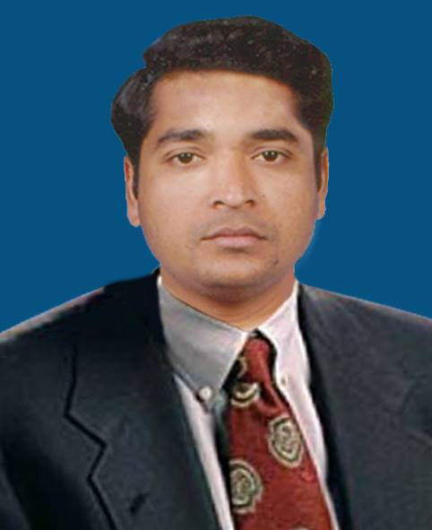

- EDUCATIONAL AREA:-
Teaching Experience: - 8 Years
Assistant Professor in Shri.Ravsaheb Ramrav Patil College,Savlaj Tal. : Palus, Dist.: Sangli
(09th September 201 to 25th June, 2012)
Assistant Professor in Abasaheb Marathe Arts and New Commerce, Science College,
Rajapur Dist. – Ratnagiri. (26th June, 2012 to 15^{n} June, 2017)
Assistant Professor in Arts,Science And Commerce College Ramanandnagar (Burli)
(16^{n} June, 2017 to Till Date)
Current Position
Assistant Professor of Economics
Arts,S cience And Commerce College Ramanandnagar (Burli)
Educational Qualification: - M.A., M.Phil., Ph.D.(Reg.), SET (Economics)
Name of Examination | Board/University | Year of Passing | Percentage/Grade
Ph. D. | Shivaji University, Kolhapur | July, 2018 | Registered
SET | UGC Recognized Conducted by S.P. University, Pune | Feb. 2008 | Qualified
M. Phil. | Shivaji University, Kolhapur. | Feb. 2008 | ‘A’ Grade
M. A. | Shivaji University, Kolhapur. | 2005 | 58.50%
B. A. | Shivaji University, Kolhapur. | 2003 | 56.50%
H. S. C. | Pune Board | 2001 | 65.00%
Computer Knowledge:-
Computer course in MS-CIT.
- PERSONAL DETIALS:-
Date of Birth: - 20, June 1982.
Language known: - Marathi, Hindi, English.
Marital Status: - Married.
Nationality: - Indian.
Blood Group: - B⁺ -Positive.
Hobbies: - Reading, playing cricket etc.
- RESEARCH AREA:-
Title of M. Phil Dissertation:-
“Finances of Village Panchayat A Case Study of Hupari Village Panchayat”
Ph.D. Reg.:-
“Agriculture Finance: A Study of Kolhapur district”
Publication of Research Papers:-
- mahamaMdI AaiNa Aqa-vyavasqaa jaagatIk va BaartIya
State Level Seminar on ‘World Economic Recession & Its Impact On Indian Economy’ organized by, D.R.Mane Mahavidyalaya,Kagal (08th & 09th, January 2010,)

- Saotk¹yaaMcyaa Aa%maha%yaa karNao va ]payayaaojanaa
State Level Seminar on ‘Benefit and Cost Analysis of Agricultural Product in Maharashtra and Farmers’ Suicide’ organized by, Dahiwadi College Dahiwadi (30th & 31st March 2012)
- Contract Farming
National Seminar on ‘Challenges before the Agriculture in Maharashtra’ organized by,Abasaheb Marathe Arts & New Commerce & Science College, Rajapur (07th & 08th March, 2014)
- A Report on MGNREG Act.
National Seminar on ‘Problems and Prospects of Mahatma Gandhi National Rural Employment Guarantee Scheme (MGNREGS) In Maharashtra’ organized by, Shri. Raosaheb Ramrao Patil Mahavidyalaya, Savlaj (21st & 22nd January, 2015) ISBN –978-5235-278-4
- The micro political Economy of Gains by unorganized women workers in India
International Conference on ‘Multidisciplinary International Research Conference On Innovation, Skill Development and Entrepreneurship organized by, Anandi Arts, Commerce and Science College Gaganbaeada (10th October, 2015) ISSN: 2249 7463
- The impact of Globalization on Agriculture co-operatives in India
National Conference on ‘The impact of Globalization on co-operative Societies’ organized by, Dr. N. D. Patil Mahavidyalaya, Malkapur (17^{h} March, 2018) ISSN : 2249 7463
- Other Activities:-
Delivered Lecture on ‘Planning Experience in India’ Organized by Staff Academy Committee Abasaheb Marathe Arts & New Commerce & Science College, Rajapur (16th April, 2014)
- Worked As A Convener
National Seminar on ‘Challenges before the Agriculture in Maharashtra’ organized by, Abasaheb Marathe Arts & New Commerce & Science College, Rajapur (07th & 08th March, 2014)
- Chairperson of Plenary Section
One Day National seminar “The impact of Globalization on Agriculture co-operatives in India” at Dr. N. D. Patil Mahavidyalaya, Malapert (17^{h} March, 2018)
- UGC Sponsored Orientation Programme Organized by, Human Resource Center Kumaun University Nainital (Uttarakhand) (04th April,2015 To 02nd May,2015)
- UGC Sponsored Refresher Course Organized by, Human Resource Center Ranchi University, Ranchi (Jharkhand) (18th May,2016 To 07th June,2016)

